Diversity and Inclusion Policy
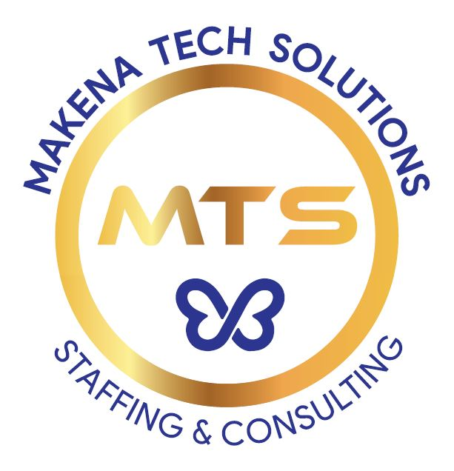

Makena Tech Solutions recognizes its responsibility as a staffing provider to foster a diverse and inclusive environment for its employees, clients, candidates and community. Our human capital is the most valuable asset we have. The collective sum of the individual differences, life experiences, knowledge, inventiveness, innovation, self-expression, unique capabilities and talent that our employees invest in their work represents a significant part of not only our culture, but our reputation and company’s achievement as well.

We embrace and encourage our employees’ differences in age, race, disability, ethnicity, family or marital status, gender identity or expression, language, national origin, physical and mental ability, political affiliation, race, religion, sexual orientation, socio-economic status, veteran status, and other characteristics that make our employees unique.

Our mission is to ensure fairness, equality and diversity in the workforce by striving to know and understand the needs of our employees and candidates. We acknowledge the differences that exist and we celebrate those differences.

We foster a company culture where every voice is welcome, heard and respected. A place where every employee and candidate feels valued for their ideas, background and perspective. We embrace diverse thinking, allowing people from all walks of life to share their vastly different perspectives.

All employees of Makena Tech Solutions have a responsibility to treat others with dignity and respect at all times. All employees are expected to exhibit conduct that reflects inclusion during work, at work functions on or off the work site, and at all other company-sponsored and participative events.

Any employee found to have exhibited any inappropriate conduct or behavior against others may be subject to disciplinary action.

Employees who believe they have been subjected to any kind of discrimination that conflicts with the company’s diversity policy and initiatives should seek assistance from a supervisor or an HR representative.

